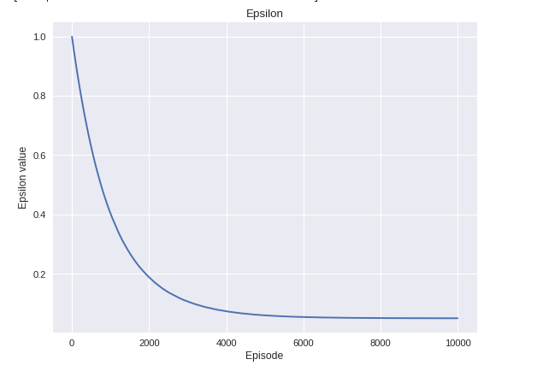

Lambda =0.0001

M=6.72

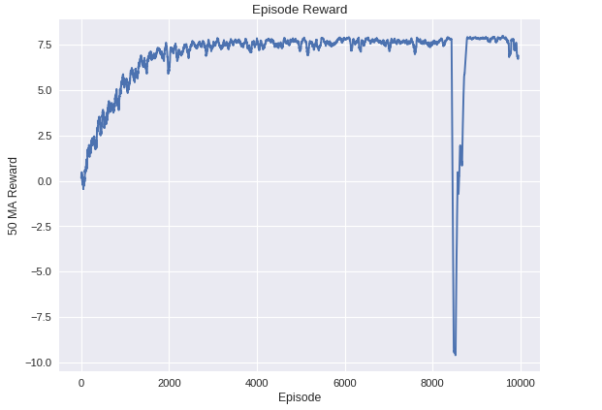

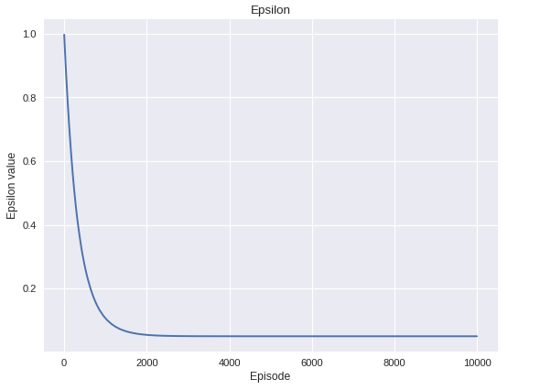

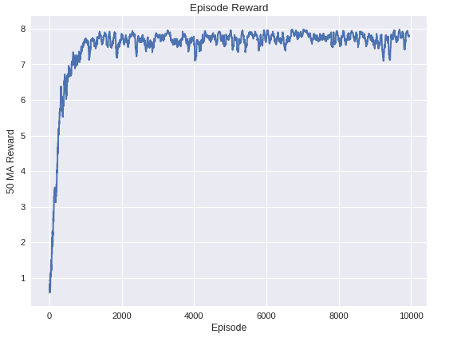

Lambda =0.0003

M=7.48

|  |  |  |  |  |
| --- | --- | --- | --- | --- |
|  | lambda | epsilon | Total time  taken | Mean Reward |
|  | 0.00001 | 0.407 | 866 | 3.14 |
|  | 0.00005 | 0.060 | 834 | 6.35 |
|  | 0.0001 | 0.050 | 814 | 6.72 |
|  | 0.0003 | 0.05 | 809 | 7.48 |